Assignment for the Urban Tour – TIG Urban Education

ETEN conference 2024 Leeuwarden

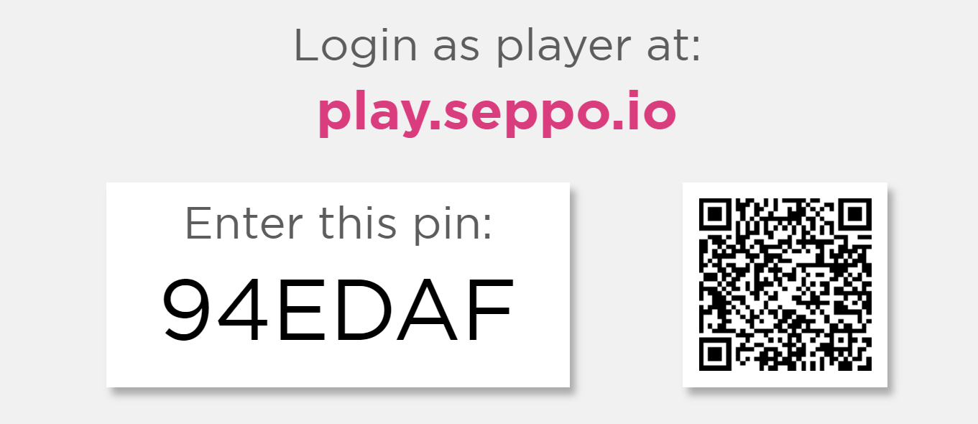

Paper (back) up version

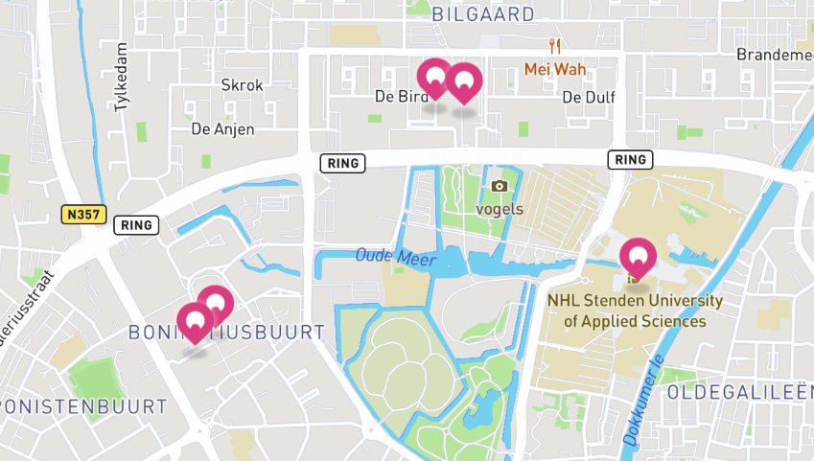

Game story
The citywalk through the northern part of Leeuwarden offers an opportunity to explore the living environment of children from various perspectives. You will discover new opportunities for educational enrichment. One aspect of this exploration is the opportunity to view the environment through different lenses.
Moreover, you'll also be able to identify opportunities for risky play within different settings. Risky play, which involves activities like climbing trees, exploring rough terrain, or engaging in imaginative adventures, is crucial for children's physical and cognitive development.
You will discover at two different sites whether the places encourage or inhibit such activities. Are there elements that invite children to push their boundaries and test their skills, or do safety concerns overshadow opportunities for exploration and adventure?
Today we will explore the city of Leeuwarden. If you look at the city from the perspective of people and the world, various disciplines come together in the city. You can look at the city from the historical perspective, the natural perspective, socio-economic perspective but also the perspective of arts.
It just depends on what you want to see.
The theme of this tour is.....
What if the city would be the school?
• Who is the teacher then?
• What is the classroom?
• What do you use as teaching material?
• What does learning contribute?
You will visit different places in the city of Leeuwarden and at various times you will be asked to do exercises to look, observe and think about how you can use the environment for your education.

Start at University of Applied Science NL Stenden
The citywalk through the northern part of Leeuwarden starts at the University of Applied Science NL Stenden.
Half of the group proceeds to the district of Sonnenborgh, while the other half heads towards the disctrict of Bilgaard.
During the walk, you'll make images of extraordinary places that offer enrichment for educational purposes. Be sure to view the environment through different lenses. Consider the historical lens, exploring landmarks or sites with significant historical importance. Delve into the economic lens by examining areas of commerce or industry, noting how economic activities shape the landscape. Additionally, observe through the demographic lens, paying attention to the social dynamics and how people interact within the community.
Furthermore, keep an eye out for opportunities for mathematical education, such as architectural marvels that demonstrate geometric principles. Maybe you see spaces that lend themselves to language education, whether through bilingual signage, literary landmarks, or multicultural neighborhoods that foster language diversity. By exploring these various perspectives, you'll discover a wealth of educational opportunities embedded within the cityscape
It just depends on what you want to see. The theme of this tour is.....
What if the city would be the school?
Let's delve into the educational wonders of our surroundings together!
First assignment send in your answers to the following questions!
What if the city would be the school?
* Who would be the teacher then?
* What is the classroom like?
* What do you use as teaching materials?
* What does learning contribute?
The second assignment involves recognizing possibilities for risky play, which are essential for children's development. Here are some categories to consider:
Play with Heights: Look for opportunities for children to climb trees, scramble up rocks, or explore elevated structures like climbing frames or play towers.
Play at High Speeds: Identify areas where children can engage in activities that involve speed.
Play with Tools: Find spaces where children can use tools or equipment, s
Play Near Elements: Seek out environments where children can interact with natural elements like water, sand, or mud.
Play with a Chance of Getting Lost: Explore areas that provide opportunities for children to navigate and explore independently.
Rough-and-Tumble Play: Identify spaces where children can engage in physical play that involves wrestling, chasing, or playful fighting.
During the journey to the next site, you send in pictures, text, video or audio highlighting sites that offer opportunities for risky play.

Go to district of Sonnenborgh

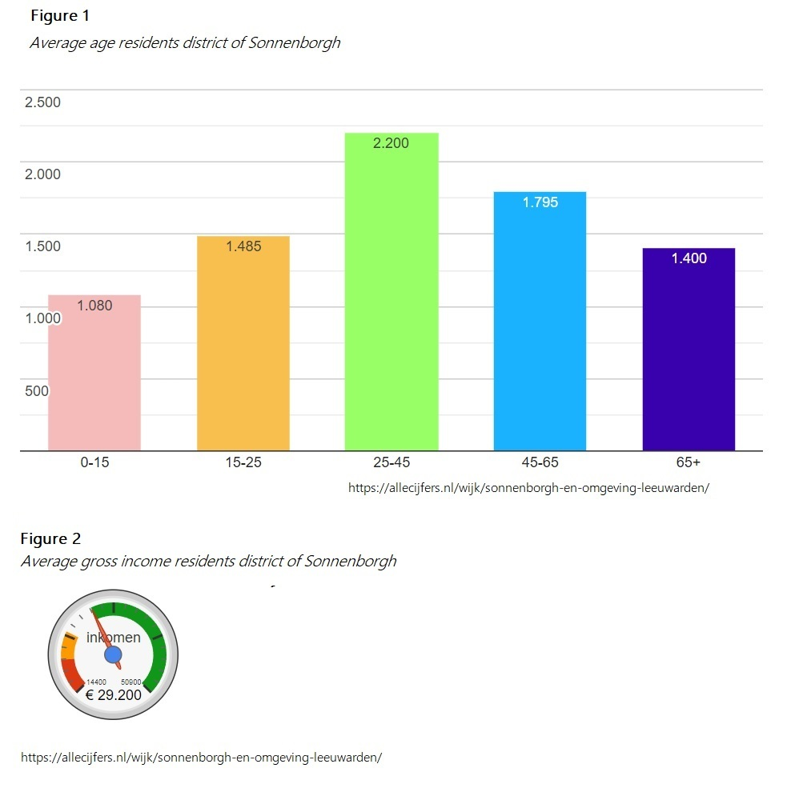
Send in your answers to the questions:
What if this part of the city would be the school?
Who would be the teacher then?
What is the classroom like?
What do you use as teaching materials?
What does learning contribute?

Risky play at the district of Sonnenborgh
Discover the district of Sonnenborgh and send in pictures, text, video or audio highlighting sites that offer opportunities for risky play.

Play with Heights: Look for opportunities for children to climb trees, scramble up rocks, or explore elevated structures like climbing frames or play towers.
Play at High Speeds: Identify areas where children can engage in activities that involve speed.
Play with Tools: Find spaces where children can use tools or equipment, s
Play Near Elements: Seek out environments where children can interact with natural elements like water, sand, or mud.
Play with a Chance of Getting Lost: Explore areas that provide opportunities for children to navigate and explore independently.
Rough-and-Tumble Play: Identify spaces where children can engage in physical play that involves wrestling, chasing, or playful fighting.

Go to district of Bilgaard

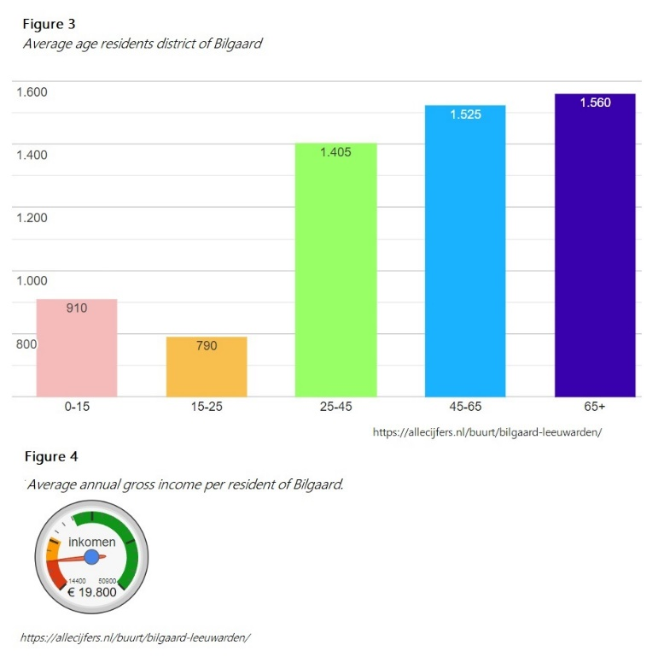
Send in your answers to the questions:
What if this part of the city would be the school?
Who would be the teacher then?
What is the classroom like?
What do you use as teaching materials?
What does learning contribute?

Risky play at the district of Bilgaard
Discover the district of Bilgaard and send in pictures, text, video or audio highlighting sites that offer opportunities for risky play.
Elements of risky play
Play with Heights: Look for opportunities for children to climb trees, scramble up rocks, or explore elevated structures like climbing frames or play towers.
Play at High Speeds: Identify areas where children can engage in activities that involve speed.
Play with Tools: Find spaces where children can use tools or equipment, s
Play Near Elements: Seek out environments where children can interact with natural elements like water, sand, or mud.
Play with a Chance of Getting Lost: Explore areas that provide opportunities for children to navigate and explore independently.
Rough-and-Tumble Play: Identify spaces where children can engage in physical play that involves wrestling, chasing, or playful fighting.

