Abstract of the workshops – Arts in Education TIG Hasselt 2025

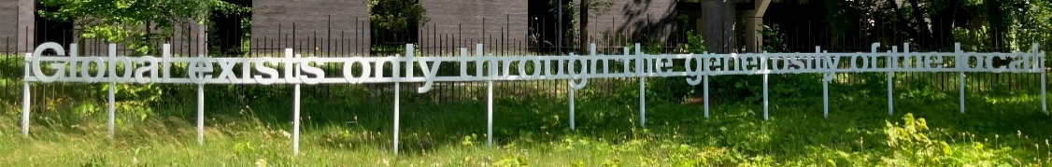

Education TIG 2025 in Hasselt Belgium, we had a wide range of different practical/theoretical workshops. After a nice group dinner in a local restaurant in Hasselt the members of the Arts in Education Tuesday evening we began the 7th of May by meeting up at local inside- and outside (24-hectare park) museum called LABIOMISTA, 30 min. away from Hasselt in a smaller town called Genk. LABIOMISTA is a permanent and evolving work of art that invites, challenges and inspires for a wealth of creations, projects and collaborations between artist and city, people and society. And it’s a meeting place for all the species of this world from chickens to sculptures, architecture and living artworks and installations. We had a one our walk/workshop facilitated by a Belgian art specialist and a guided tour talking about the vision of the owner artist Koen Vanmechelen and his life's work in terms of identity, fertility & biocultural diversity. https://www.labiomista.be/en

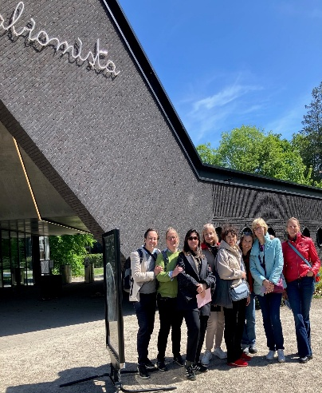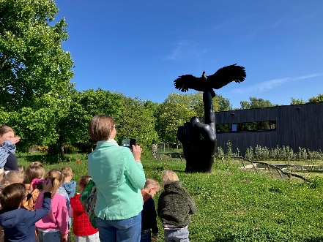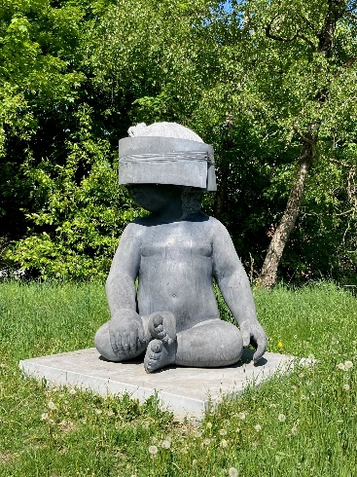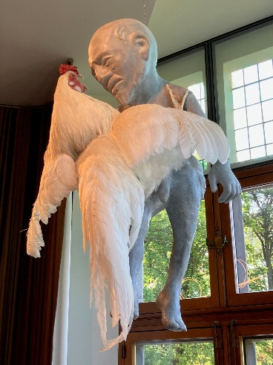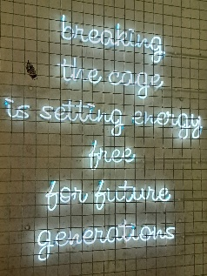

Our 1st participant workshop called Using music to bridge between conflicting groups was done online (because of force majeure) by Dr. Elana Baruch and Dr. Maya Yair from David Yellin Academic College of Education and Bar-Ilan University, Israel.
Elena and Maya have developed a model for using music therapy to enhance dialogue in a multicultural population, and between conflicting groups. There work encourages the ability to listen to the multitude of voices and emotional overtones that exist between the participants, especially those that are silenced or marginalized as a result of conflict. They presented the basic principles of their model, while providing examples that allowed the participants to experience the power of music in contradictory situations as we talked only through music for a while. It was very interesting to see how our little group tried to communicate only through music and sound. Finally, we reflected on these experiences and talked about multiculturalism and conflict environments where these ways of communication can be applied.
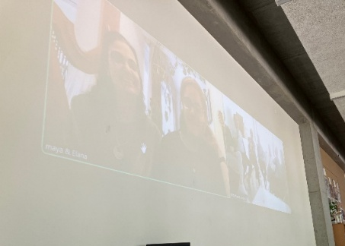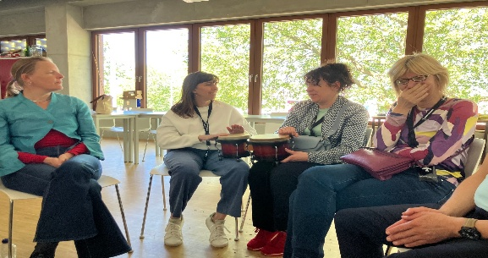

2nd workshop was Derya Akgure, lecture in Early Childhood Education, Hogeschool PXL, gave a delightful workshop Creatively Engaging with Media and 21st-Century Skills.
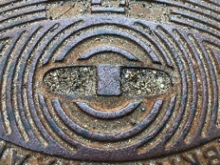
She inspired and equipped us with strategies to integrate media into arts education, with a strong emphasis on fostering creativity and artistic expression. Many schools today have access to tablets and computers, these tools are often primarily used for technical and practical purposes, but in this workshop, we looked at the artistic and creative potential of digital media, demonstrating how technology can serve as a powerful tool for creative expression and artistic growth in children. Doring the workshop we tried to find faces in strange places:
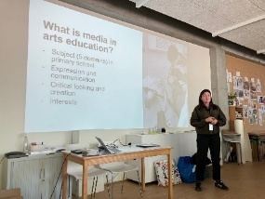
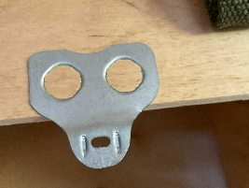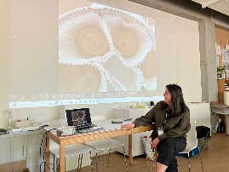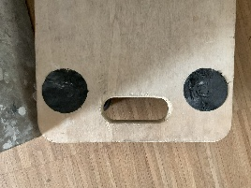

3th workshop. We experienced an exciting and practical workshop Activities for children's self-expression in preschool. The main thing is colors as a means of expression by Vineta Pole, Jana Grava og Linda Pavitola from Latvia. We discussed; What creates a child’s inner motivation? What bring children joy? And how do we show and create environments for children so that they can use their possibilities and abilities? The group showed us several fun methods of using paper drawing and storytelling to express different emotions. In pairs we drew each other and ourselves on a piece of paper. It was exciting to see how we draw our own ideas about what we look like next to the vision that others see or can express in drawing.
Afterwards we let chance choose where to place different shapes on a piece of paper. They were glued and then through colors and drawing we created a picture with an associated story that we could name and tell the group. The name of the picture we created was also the motto of our life!

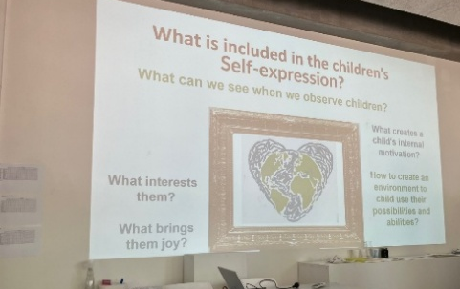
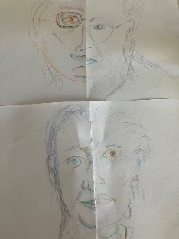
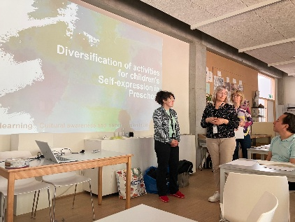
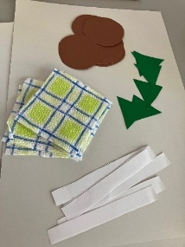
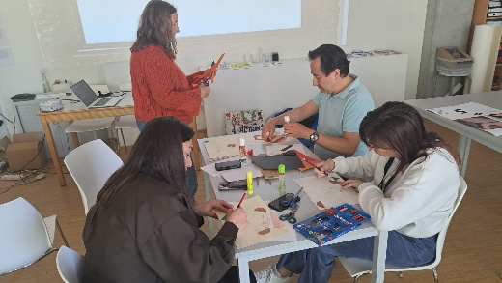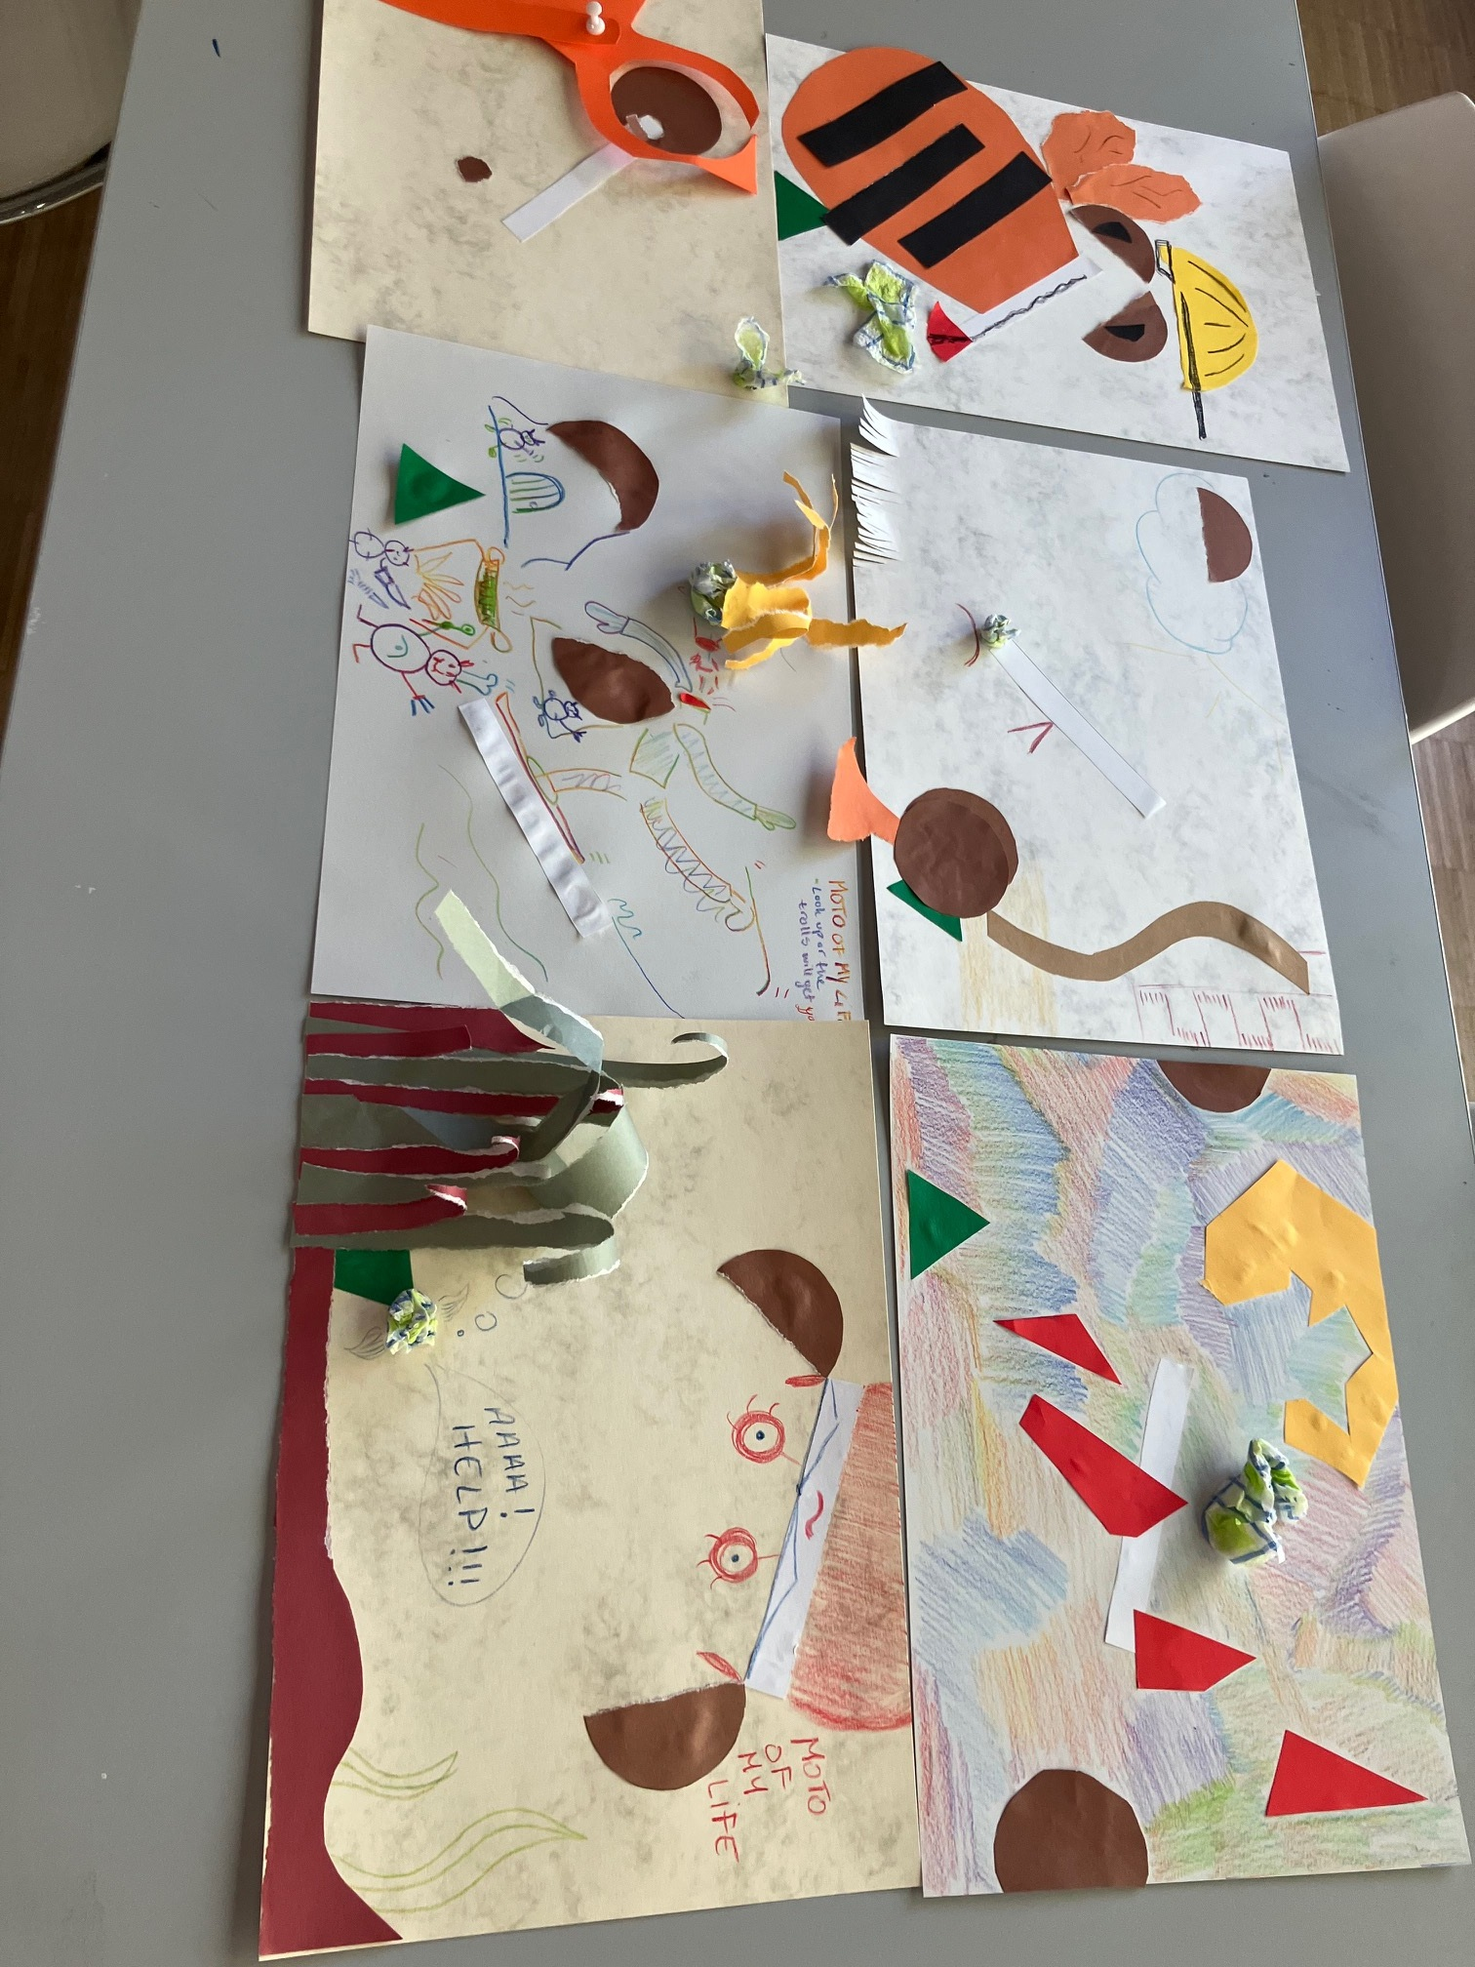

Jorinde Jonker, The Netherlands told us about a Theater project in the woods of Rotterdam.
Each autumn the TMH is organizing a big art project. The first week is in Rotterdam, hometown of the institute, where the second-year students visit art institutions such as the Philharmonic orchestra, Maaspodium (theatre) and Melly (contemporary art institute), sometimes with children.
During the second week the project is on location for one week in the woods at Vierhouten. Through all kinds of associative exercises, the students make a visual performance with their own class.
What is extra special about this project is that most of the activities are guided by the students of the fourth year, which have chosen minor culture education. Of course, with supervision of the art teacher’s department. Due to this structure everyone learns at the maximum and it makes it possible to organize it for a big group of students with a small group of teachers.

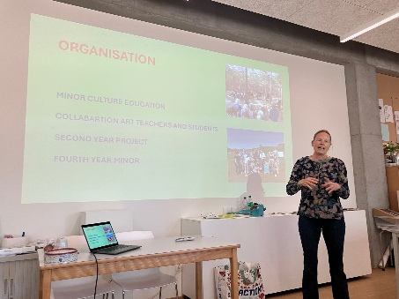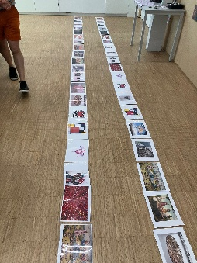
We ended the Arts in Education Tig by talking about the importance of using real experiences as nature and living culture as an inspiration in our different education systems and how we enjoy getting inspired by the rest of the TIG members. We are looking forward to meeting all our friends, and new friends, next year in Albania and get more playful experiences together YOU are welcome to
– Mitte Wagner, TIGLeader and Jorinde Jonker, TIGLeader!

