Collage Across Borders: A COIL Partnership with KDG Belgium
Dr Lucy Barker, Northumbria University
A small but significant cross-cultural Arts Based Education Research project has been quietly unfolding between Northumbria University, Newcastle and Karel de Grote (KdG) University College in Antwerp, Belgium, one that puts collage at the heart of international pedagogy.
The partnership, initiated following Lucy Barker's presentation on collage as inquiry at the European Teacher Education Network (ETEN) Symposium in Hasselt in 2025, brought together undergraduate students and staff from both institutions within a Collaborative Online International Learning (COIL) framework. Students were invited to create magazine collages in response to the question: "How do you, as a teacher, make a difference for all pupils?" before sharing and discussing their work in a live 90-minute online exchange via Microsoft Teams.
Ruben De Witte, lecturer at KdG, reflected on why the collage format proved so well-suited to this group of students, many of whom are career changers or in-service trainees with limited access to traditional forms of internationalisation:
"Working with collage in small international groups proved particularly powerful. The creative process encouraged students to open up, exchange viewpoints, and engage in deeper reflection. The visual and collaborative nature of the method helped to loosen tongues, fostering rich discussions and allowing multiple perspectives on inclusion to surface."
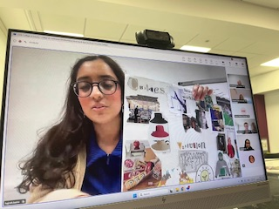
That loosening of expression was felt on both sides of the exchange. Northumbria students described the collage task as a refreshingly low-stakes way into challenging ideas. As one Northumbria student put it:
"I found it really relaxing, and it felt like a low-stakes way to communicate my ideas around inclusion. Using the collage to convey metaphors about inclusion encouraged me to think less traditionally and in a more creative and expressive way."
Others noted how the visual medium bridged what written or spoken tasks sometimes cannot. Another Northumbria student observed that despite a minor language barrier, "we were all able to make meaning of each other's collages through the visuals" a reminder that arts-based methods can create genuine communicative access across cultural and linguistic difference.

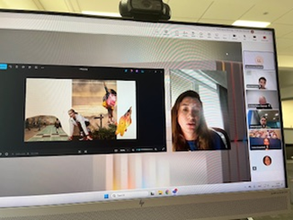
Perhaps most striking was the sense of shared values that emerged across two quite different educational systems. A year 3 Primary Education student reflected:
"Whilst inclusive practice covers a wide range of topics and ideas, there is a collective idea of what inclusive practice is regardless of background or culture. This therefore showed me that inclusive practice is a concept that is not only agreed on locally, but also worldwide."
The KdG students, too, produced work of striking depth. One pair responded to the prompt not just with a collage, but with a poem, translated from Dutch, which opened with the lines: "Not every child starts out equal / some carry more burdens / I see their beginnings." It is a reminder of what becomes possible when students are invited to make meaning, rather than simply report it.

Research Opportunities

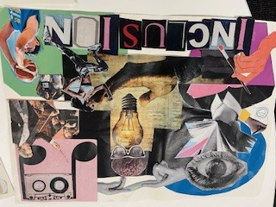
This project offers rich potential for the Arts-Based Educational Research (ABER) community. Future iterations, planned to reach larger cohorts in UK and Belgium and other countries, will generate visual artefacts, reflective commentary, and interview data well-suited to arts-based analysis. We are particularly interested in collaborators with expertise in teacher education, visual methods, inclusive pedagogy, or internationalisation, and are open to co-authorship or shared data collection across institutions.
To find out more or explore collaboration, contact Dr Lucy Barker l.a.barker@northumbria.ac.uk

